SouMoster Apps — Website Design Document
Nov 1, 2026 · @SouMo

Overview
SouMoster Apps is one static website on Vercel that showcases every SouMoster utility app — today ScanPocket, PlayPocket, NotesPocket and ReadPocket — and takes new apps by adding one content file. It is the sister of the SouMoster games site and shares its brand, with a calmer, utility-first tone.
Audience
- Android users who find an app on Google Play and want to know who made it and what else exists.
- Reviewers and Play Store policy checks that need a stable privacy policy and support page per app.
- Players of SouMoster games who follow the studio link across.
Goals
- Show the whole Pocket family on one page, each app with its own accent colour and one-line promise.
- Give every app a detail page: what it does, screenshots, privacy facts and a Google Play link.
- Host each app's privacy policy at a permanent URL for its Play Store listing.
- Feel like the same studio as the games site at first glance.
- Add a future app without touching layout code.
Non-goals
- No accounts, sign-in, comments or newsletter backend.
- No in-browser versions of the apps.
- No tracking beyond cookieless page-view counts.

Design cues from the games site
The apps site reuses the SouMoster games site's skeleton: dark slate base, frosted-glass cards, Poppins headlines, one violet accent, status badges. It swaps arcade energy for calm: fewer moving parts, more white space, and each app's own accent instead of game art.
Games site element | What it is there | Apps site version
Page base | Slate #0f172a, text #f8fafc, muted #94a3b8, borders #334155 | Same tokens, so both sites read as one studio
Primary accent | Violet #6C63FF on buttons, pills and links | Same violet for site chrome; each app card adds its own accent
Hero headline | Poppins 700, 60 px, gradient violet → amber → green, uppercase tracked "SOUMOSTER" eyebrow | Same layout; gradient runs across the four Pocket accents
Hero art | Tilted collage of game tiles with status badges | Fanned stack of phone frames, one per app, showing each lock screen
Glass cards | rgba(30,41,59,.65), 1 px white/10 border, 16 px radius, image zooms 5% on hover | Same card for app tiles; icon tile replaces cover art
Status badges | Live · Closed test · In development | Same three, plus Coming soon for unannounced slots
Ticker | Endless marquee of game names with ✦ separators | One slow marquee of app names and promises; paused for reduced motion
Stat counters | Games live, downloads, games in testing, years | Apps live, apps in testing, 0 accounts needed, 0 ads
Catalogue filter | Genre chips with counts: All (6), Arcade (4) | Category chips: All, Documents, Media, Notes
Spotlight band | "Now in closed testing" feature with Join and Learn more | "Newest app" or "Now in testing" band, same layout
Studio pillars | Fun First · Tested With Players · Built to Last | Private by default · Works offline · Built to last
Header | Fixed, transparent until scroll; Home, Apps, About, Beta, Support, Blog, Contact; Download button; language and theme toggles | Same header; a "Games" link points back to the games site
Stack | Next.js App Router, Tailwind CSS, Inter + Poppins, on Vercel | Same stack, so components can move between the two repos
The games site already uses /apps for its games. The two sites need a clear split of names and links — see Open questions.

Visual system
The site is dark-first like the games site, with a light theme behind the same toggle. Studio chrome uses the shared slate and violet tokens; each app brings exactly one accent, the same colour its Android theme uses, so a card on the web matches the app on the phone.
Studio tokens (CSS variables, Tailwind theme)
Token | Dark (default) | Light | Use
--background | #0f172a | #f8fafc | Page
--card / --glass-bg | #1e293b / #1e293ba6 | #ffffff / #ffffffcc | Cards, header after scroll
--foreground | #f8fafc | #0f172a | Body text
--muted | #94a3b8 | #475569 | Secondary text
--border / --glass-border | #334155 / #ffffff1a | #e2e8f0 / #0f172a14 | Card and divider lines
--primary | #6C63FF | #5B52E6 | Buttons, links, pills
Light values are proposals; align them with the games site's light theme before build.
App accents (from each app's Compose theme)
App | Accent, light | Accent, dark | Character
ScanPocket | #2458CE | #A9C7FF | Clear blue
PlayPocket | #B13A0B | #FFB59B | Warm ember
NotesPocket | #1B6B51 | #8FD5B5 | Leaf green
ReadPocket | #6552A3 | #CEBAFF | Ink violet
An app's accent sets its icon tile, card glow, badge tint and detail-page hero. It never colours body text, so contrast stays the studio's.
Type
- Headlines: Poppins 600–700, tight tracking (−1.5 px at 60 px, −0.9 px at 36 px).
- Eyebrows: Poppins 600, uppercase, 0.3 em tracking, muted colour.
- Body and UI: Inter 400–600, 16 px base, 1.6 line height.
- Both via next/font, self-hosted, with display: swap.
Shape and depth
- Radii: 12 px buttons, 16 px cards, 24 px hero panels, full pills; the 22 px icon tile matches the apps' lock-screen tile.
- Depth from glass and borders, not drop shadows; a soft radial glow in the accent sits behind the hero and app heroes, echoing the apps' lock screens.
Motion
- Hover: card border shifts to the accent at 50% and the art zooms 5% over 500 ms.
- Entry: sections fade up 16 px once, on scroll into view.
- Ticker and stat counters run once or slowly, and stop entirely under prefers-reduced-motion.

Information architecture
The site has six top-level pages and two pages per app; everything a visitor needs is at most two clicks from Home.
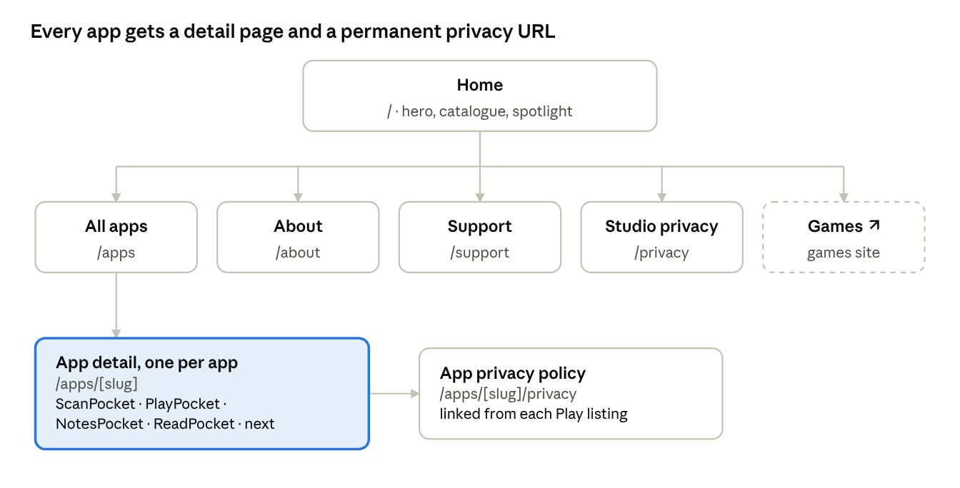
sitemap · 6 top-level pages, 2 per app
The app detail page is the template that repeats; its privacy page is the URL each Google Play listing links to, so that path never changes. Games links out to the games site.
Page | Sections, top to bottom
Home / | Header · hero (eyebrow "SOUMOSTER APPS", headline "Small apps. Big pockets.", promise "Offline Android tools with no account and no ads", buttons Explore the apps / Games by SouMoster) · app ticker · stat strip · "The Pocket family" grid with category chips · spotlight band · three pillars · footer
All apps /apps | Header · title and chips · full grid, including Coming soon cards · footer
App detail /apps/[slug] | Hero in the app's accent (icon tile, name, tagline, status, Play badge, phone frame with its lock screen) · screenshot rail · feature grid · privacy facts · version and minimum Android · "More Pockets" row of the other apps · footer
App privacy /apps/[slug]/privacy | Plain reading page: app name, last updated date, policy text, contact
About /about | Who SouMoster is, how apps are made and tested, link to the games site
Support /support | Per-app FAQ accordions, contact email, how to report a bug
Studio privacy /privacy | What the website itself collects (page views only)
The hero headline and promise are draft copy for review.

App catalogue
The launch catalogue is the four Pocket apps; all share one promise — offline, no account, no ads — and differ in what they hold. Taglines are the ones each app shows on its own lock screen, so the site and the apps say the same thing.
App | Tagline | Category | Highlights for the detail page | Package | Version | Min Android
ScanPocket | Documents, text and QR codes | Documents | Scan to clean PDFs, QR scan and create, sign and edit pages, app lock | com.scanpocket | 1.0.0 | 8.0
PlayPocket | Videos and music, offline | Media | Folder-first player, background audio, playlists and favourites, subtitles, equaliser | com.playpocket | 1.0.0 | 10
NotesPocket | Notes, checklists and reminders | Notes | Notes and checklists, labels, reminders, images, app lock | com.notespocket | 1.0.0 | 8.0
ReadPocket | Read, mark up and sign PDFs | Documents | Continue reading, highlights and notes, fill and sign forms, merge PDFs, encrypted backups | com.readpocket | 0.1.0 | 8.0
Versions and minimum Android come from each project's build file as of today; the site reads them from content files, not code.
Future apps take a card with the Coming soon badge, a name, a one-line promise and, if the accent is not settled, the studio violet. A "More Pockets on the way" card closes the grid until the next app is announced.

Components
Thirteen components build every page; each takes an app's content record and its accent, so a new app needs no new component.
Component | What it shows | Behaviour | Games site origin
Site header | Logo, Home, Apps, Privacy, Support, Games ↗, theme toggle, Get on Google Play | Transparent, turns glass after 24 px scroll; collapses to a sheet under 768 px | Header
Hero | Eyebrow, gradient headline, one-line promise, two buttons, fanned phone frames | Phones fan out on load once; static under reduced motion | Hero + tile collage
App ticker | App names with promises, ✦ separators | 40 s loop, pauses on hover and reduced motion | Marquee
Stat strip | Four counters | Counts up once in view | Stat counters
Category chips | All, Documents, Media, Notes, with counts | Filters the grid client-side; URL keeps ?category= | Genre chips
App card | Icon tile in accent, name, tagline, status badge, version, two highlight chips | Whole card links to the detail page; border takes the accent on hover | Game card
Status badge | Live · Closed test · In development · Coming soon | Colour from status, never from app | Status badge
Spotlight band | One app: name, tagline, three facts, Get it or Join test buttons | Set by a spotlight: true field | Closed-testing band
Feature grid | Six features: icon, title, one sentence | 3 × 2 on desktop, one column on phones | Studio pillars
Screenshot rail | 4–8 phone screenshots in device frames | Horizontal scroll-snap, arrow buttons, keyboard focusable | —
Privacy facts | Account needed, ads, internet permission, data stored, export | A fixed five-row list per app, read from content | —
Play badge | Official Google Play badge, or Join test link | Hidden for Coming soon apps | Download button
Footer | Apps list, Games, Privacy, Support, Contact, credit line "Designed with ❤️ by SouMoster" | Same credit the apps carry on their lock screens | Footer

Content model
Each app is one MDX file in content/apps/: front matter holds the facts the components render, the body holds the long description. Adding an app is a pull request with that file and an public/apps/<slug>/ folder; pages, grid, chips, sitemap and OG images pick it up at build time.
# content/apps/readpocket.mdx (front matter)
slug: readpocket
name: ReadPocket
tagline: Read, mark up and sign PDFs
category: Documents
status: in-development # live | closed-test | in-development | coming-soon
order: 4
spotlight: false
accent: { light: "#6552A3", dark: "#CEBAFF" }
icon: /apps/readpocket/icon.svg
package: com.readpocket
version: 0.1.0
minAndroid: "8.0"
playUrl: https://play.google.com/store/apps/details?id=com.readpocket
testUrl: null
highlights: [Continue reading, Highlights and notes, Fill and sign forms]
features:
- { icon: bookmark, title: Pick up where you left off, body: Every PDF reopens on the page you closed. }
screenshots: [lock.png, home.png, library.png, reader.png]
privacy:
account: false
ads: false
internet: false
storage: On this phone only
export: Encrypted backup file
privacyPolicy: ./privacy.md
released: null
- A Zod schema validates every file at build; a missing field or an unknown status fails the Vercel build, not the live site.
- status: coming-soon hides the Play badge, version and screenshots, and needs only name, tagline and order.
- Each app's privacy policy lives beside it as Markdown and renders at /apps/<slug>/privacy, the URL its Play listing uses.
- Screenshots come from the apps' own instrumented tests where they exist (ReadPocket's AppFlowTest already saves them), so the site stays current with each release.
Adding a future app
- Copy content/apps/_template.mdx to <slug>.mdx and fill the front matter.
- Add the icon (SVG) and 4–8 screenshots at 1080 × 2340 to public/apps/<slug>/.
- Write privacy.md from the shared template.
- Open a pull request; check the Vercel preview link.
- Merge; production redeploys in about a minute.

Tech stack and Vercel hosting
The site is a fully static Next.js App Router build on Vercel's Hobby plan, the same stack as the games site, so header, cards and badges can be shared. No server code runs at request time.
Layer | Choice | Why
Framework | Next.js (App Router), statically generated pages, TypeScript | Matches the games site; static pages cost nothing to serve
Styling | Tailwind CSS with the studio tokens as theme variables | Same utility classes as the games site
Content | MDX + front matter, validated with Zod | One file per app, checked at build
Fonts | Poppins and Inter through next/font | Self-hosted, no layout shift
Images | next/image with AVIF/WebP, phone frames as SVG | Screenshots stay sharp and small
OG images | next/og at build, one per app in its accent | Good link previews in chats and on Play
Analytics | Vercel Web Analytics (cookieless) | No cookie banner needed
Forms | Contact is a mailto: link | No backend to run
Repository
soumoster-apps/
app/ routes: page.tsx, apps/[slug]/page.tsx, apps/[slug]/privacy/page.tsx, ...
components/ header, hero, app-card, badge, feature-grid, screenshot-rail, ...
content/apps/ one .mdx per app + _template.mdx
content/pages/ about.mdx, support.mdx, privacy.mdx (studio-wide)
public/apps/<slug>/ icon.svg, screenshots/
lib/content.ts loader + Zod schema
Deployments
- GitHub repo connected to a new Vercel project, soumoster-apps.
- Every pull request gets a preview URL; main deploys to production.
- Build command next build; a schema or type error stops the deploy.
- Domain: soumoster-apps.vercel.app at launch; a custom domain can be added later in Vercel's Domains settings without code changes.
- Redirects in next.config keep old privacy-policy URLs alive if paths ever change, since Play listings point at them.

Accessibility, performance, SEO and privacy
Every page must pass these checks in the Vercel preview before it merges; they hold the site to the same standard the apps set for large text and privacy.
Area | Requirement | How it is checked
Contrast | Text 4.5:1, large text and icons 3:1, in both themes; app accents used for text only at the dark-theme tint | axe in CI on every route
Text size | Layout holds at 200% browser zoom with no horizontal scroll | Manual pass on home and one detail page
Keyboard | Every card, chip, rail arrow and toggle reachable and visibly focused | Manual tab-through
Motion | Ticker, counters, hero fan and fade-ins off under prefers-reduced-motion | Toggle in DevTools
Screen readers | One h1 per page, badges read as text, screenshots carry alt text from content | VoiceOver / TalkBack spot check
Speed | Lighthouse mobile ≥ 95 performance; LCP < 2.0 s, CLS < 0.05 on home | Lighthouse CI on previews
Weight | Home under 300 KB transferred before images load | Vercel build output
SEO | Per-page title and description, canonical URLs, sitemap.xml, robots.txt, SoftwareApplication JSON-LD per app | Rich Results Test
Sharing | One OG image per app in its accent | Link preview check
Privacy | No cookies, no third-party scripts, cookieless analytics only, so no consent banner | Network tab on first load
Legal | Studio privacy policy plus one policy per app at a permanent URL | Links from each Play listing resolve
The games site shows a cookie banner; the apps site avoids one by loading nothing that sets cookies.

Milestones and open questions
The build runs in four phases; each ends at a gate anyone can check, and no dates are set yet.
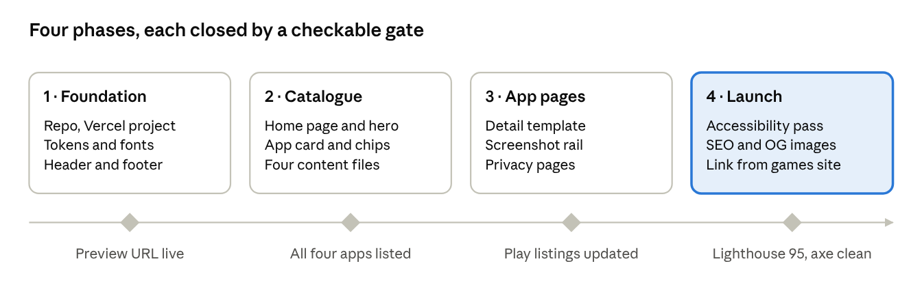
build roadmap · 4 phases, 4 gates
Phase 3's gate depends on the Play Console: each listing's privacy-policy field moves to its new /apps/<slug>/privacy URL.
Open questions
- ☐ Naming: the games site already uses /apps and calls its games "apps". Rename that to /games, or call this site "SouMoster Tools"?
- ☐ Domain: stay on soumoster-apps.vercel.app, or buy a domain and put games and apps on subdomains of it?
- ☐ One site or two: merge into the games repo as an /apps section later, or keep two Vercel projects?
- ☐ Status per app: which Pocket apps are Live on Google Play, in closed testing, or still in development?
- ☐ Store links: confirm the release package names and Play URLs for all four apps.
- ☐ Languages: the games site has a language switch; does the apps site launch in English only?
- ☐ Hero copy: approve or replace "Small apps. Big pockets." and its promise line.

